AM000-Asia-Japan-Edo-Two Cranes-Black Pine-Bamboo-Turtle-1600-1868

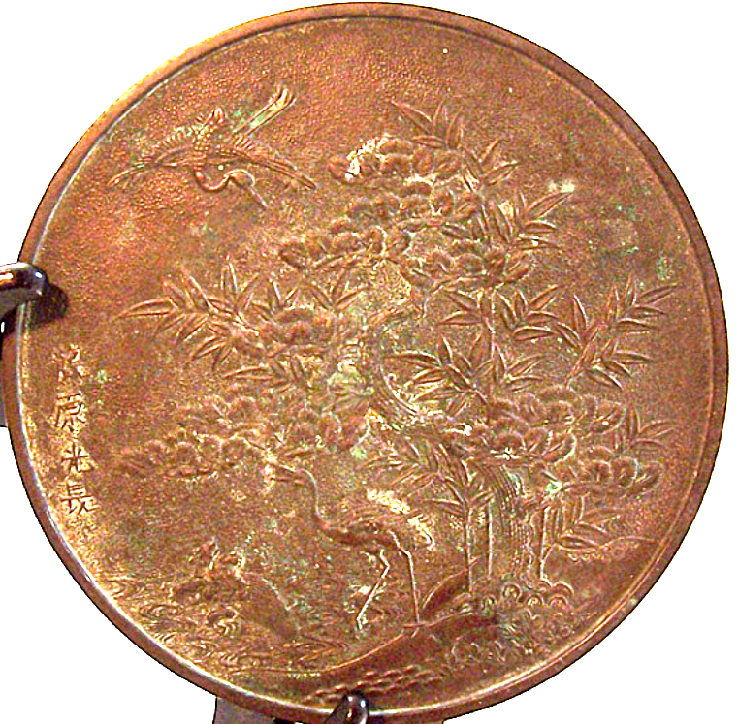

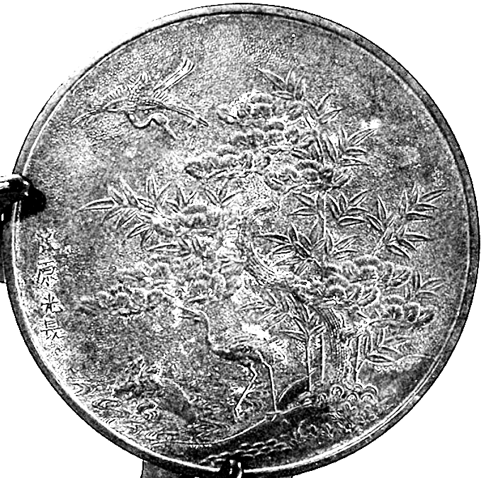

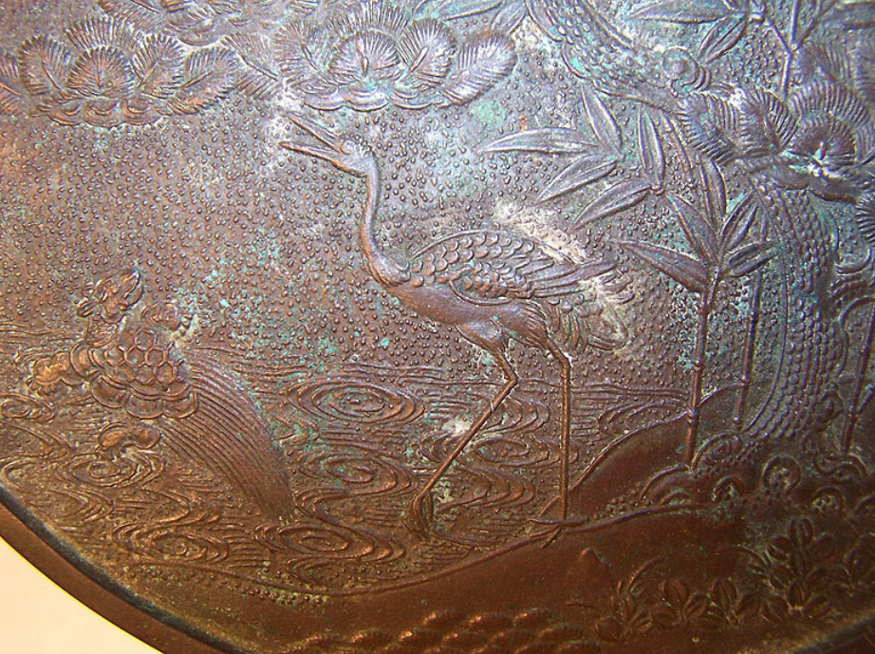

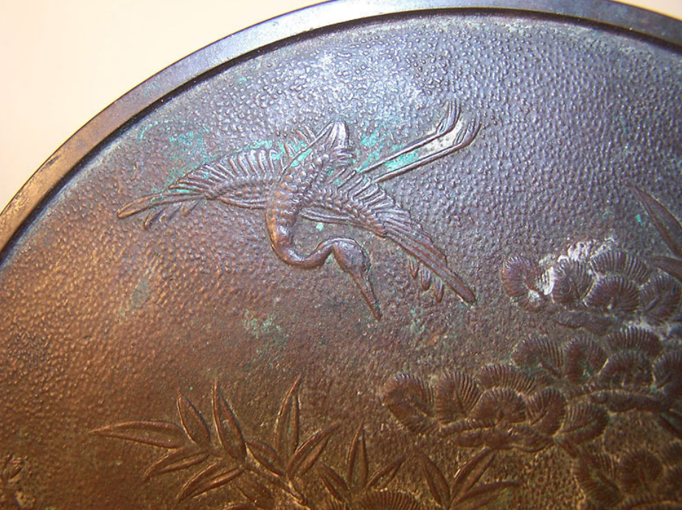

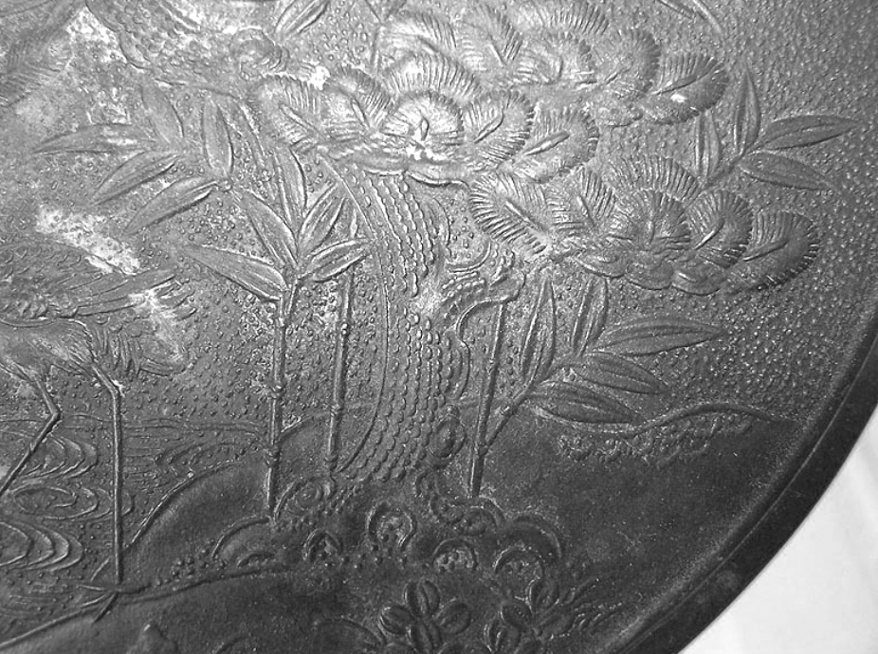

Case No.: Mirrors

Accession Number:

Formal Label: Asia-Japan-Edo-Two Cranes-Black Pine-Bamboo-Turtle-1600-1868

**Display Description:**

This is an exquisite mid-nineteenth century Japanese Edo Period (1600-1868) bronze mirror in excellent condition and shows two cranes and turtle symbolizing a successful and happy union of two people and their progeny.

Bronze mirrors were introduced into Japan from China and Korea during the Yayoi period (300 BCE – 300 CE). At first they had a religious function and were regarded as symbols of authority. The Japanese soon learned to make their own mirrors using the lost-wax technique, decorating them with Chinese or native Japanese designs.

By the Nara period (710 -794 CE) mirrors were being made for everyday use, with the increasing use of Japanese designs, such as native plants and animals symbolizing good fortune. From the Kamakura period (1185-1333 CE) a design showing Hôraizan (the Chinese 'Island of Immortality') became popular.

Mirrors gradually became more robust. They mostly have a central boss, often in the shape of a tortoise, which was pierced and a cord passed through for holding. More new designs and the first handled mirrors appeared in the Muromachi period (1333-1568).

During the Edo period (1600-1868), mirrors decorated with auspicious symbols such as two cranes and a pine tree together with Chinese characters and were given at weddings as a symbol and an augury for a successful and happy union of two people.

The Japanese black pine kuromatsu (黒松) or matsu (松の木), Pinus thunbergii (syn: Pinus thunbergiana) is native to coastal Kyūshū, Shikoku and Honshū and shares the same felicitous meanings as Chinese and Korean pine trees -- longevity, virtue, and youth. The pine tree is also associated with masculinity and power. "Matsu" in Japanese means "waiting for the soul of a god to descend from Heaven". In ancient Shinto beliefs, gods were said to have ascended to Heaven on a pine tree, where they now reside on a beautiful volcanic mountain in giant or old trees. Pine trees are associated with the New Year in Japan. So much so that many Japanese hang a bundle of pine twigs and bamboo trunks known as a *Kado matsu* on their doors to receive a blessing from the gods.

LC Classification:

Date or Time Horizon: Edo period (1600-1868)

Geographical Area: Japan

Map:

GPS Coordinates:

Cultural Affiliation: The bronze lost-wax casting is of excellent quality with very minute details

**Dimensions**: It measures 112 mm in diameter   
**Weight:** 329 gm.

**Provenance**: A very nice high quality piece most certainly owned by a person of above middle class status. These mirrors were passed down from generation through generation of a family as heirlooms. These were considered a symbol of wealth and prosperity

**Condition: original.** It has a deep golden bronze patina with only small scratches on the mirror surface. The mirror surface still retains a polished surface.

**Discussion:**

Mirrors became larger as hairstyles became more ornate; some mirrors in Kabuki theatre dressing-rooms were up to fifty cm across and were placed on stands. The faces of mirrors were highly polished or burnished, with itinerant tinners and polishers specializing in this work.

Since the mirror, together with the sword and the jewel, were symbols of Imperial power, mirror-makers were deeply revered and often given honorary titles such as Tenka-Ichi ('First under Heaven'). However, this title was often misused and was officially prohibited in 1682.

**References:**

["Pinus thunbergii"](https://plants.usda.gov/core/profile?symbol=PITH2). [Natural Resources Conservation Service](https://en.wikipedia.org/wiki/Natural_Resources_Conservation_Service) PLANTS Database. [USDA](https://en.wikipedia.org/wiki/United_States_Department_of_Agriculture). Retrieved 31 Dec. 2018.

Conifer Specialist Group (1998). ["Pinus thunbergii"](http://oldredlist.iucnredlist.org/details/42423). [IUCN Red List of Threatened Species.](https://en.wikipedia.org/wiki/IUCN_Red_List) Version 2006. [International Union for Conservation of Nature](https://en.wikipedia.org/wiki/International_Union_for_Conservation_of_Nature). Retrieved 31 Dec. 2018.

Fu, Liguo; Li, Nan; Elias, Thomas S.; Mill, Robert R. ["Pinus thunbergii"](http://www.efloras.org/florataxon.aspx?flora_id=2&taxon_id=200005368). Flora of China. 4. Retrieved 31 Dec. 2018. – via [eFloras.org](https://efloras.org/), [Missouri Botanical Garden](https://en.wikipedia.org/wiki/Missouri_Botanical_Garden), St. Louis, MO & [Harvard University Herbaria](https://en.wikipedia.org/wiki/Harvard_University_Herbaria), Cambridge, MA.

**Appendix:**

AP: 600 USD